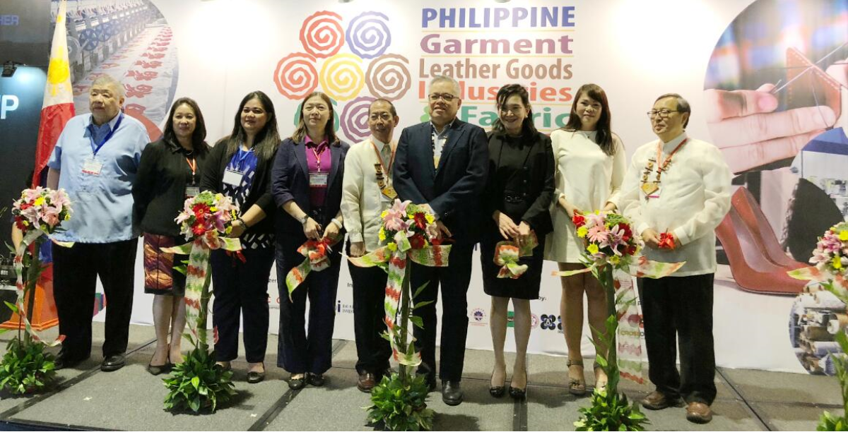
EXPO PROFILE
VIPs in the opening ceremony include 开幕式嘉宾包括:

The head of ministry, Department of Trade and Industry (DTI)

DTI secretary Ramon Lopez (the 4th from the right)
菲律宾贸工部部长 Ramon Lopez 先生(图中右四)

Mr Steven Chang
Vice President of TEXPAP

Ms Celia Elumba
Director IV of PTRI

Ms. Ma Corazon Halili-Dichosa
Board of Investments Executive Director for Industry Development Services

Ms Elaine Chiong
President of GARMAP

Mr Nick Reyes
Representative of Pasay City Government

Ms Maritess Agoncillo
Executive Director of CONWEP

Dr Clarissa Badong
MASIDO

Garment Machinery & Parts
制衣机械及零件
- CAD / CAM Systems
- Sewing
- Embroidery
- Fusing & Pressing
- Knitting
- Seam Sealing, Pleating
- Washing Drying Tumbler

Textile Machinery 纺织机械

Non-woven Machinery 无纺机械

Dye Machinery and Chemicals 印染

Industry 4.0 / Factory Automation
自动化生产

Quality Control
品质检定

Design & Computer-aided Tools & Software
设计及计算机辅助

Opportunity Fact-finding Mission
实况考察

- -- - - - - - - - - - - - - - - - - - - - - - - - - - - - - -- - - - -- - - - - - - - - - - - - - - - - - - - - - - - - - - - - - - - - - - - - - - - - - - - -
SPACE APPLICATION 参展表格  PHILIPPINE GARMENT INDUSTRY EXPO 2019  菲律宾制衣工业展览会  5 - 8 December 2019  SMX, Manila, Philippines | Please return to: CP EXHIBITION LTD  Head Office (Hong Kong)  Rm 1703, 109 Gloucester Rd, Wanchai, Hong Kong  Tel : +852 25117427 Email : sales@cpexhibition.com  Fax : +852 25119692 cpexh@yahoo.com  PETCO (Manila)  Tel : +63 2 8329305 Email : joy.fojas@petcogroup.com  +63 2 8329304 events@petcogroup.com
Co (Exhibitor) 公司:
Address 地址:
Tel 电话 : ______________________ Fax 传真 : ___________________________ Email 电邮:
Authorised Official's Name 负责人名称: __________________________________ Position 职位:

I/We the undersigned wish to participate in “PHILIPPINE GARMENT INDUSTRY EXPO 2019”
I/We accept the rules & regulations as stated in www.cpexhibition.com/cpv.pdf
Kindly reserve a booth space as indicated below. (Please choose one below)

□ | RAW SPACE 光地 ( *Surcharge for corner booth )  USD 310 per sq.m Width ________ M x Depth _________ M = USD __________  Including space, directory listing, 24-hour security and cleaning service
□ | FURNISHED CONSTRUCTED BOOTH 标准展台 ( *Surcharge for corner booth )  USD 360 per sq.m with 3M or 6M Width ________ M x Depth _________ M = USD __________  Each 9 sqm booth entitles exhibit space, carpet, walls, spot lights or fluorescent tube, power plug, chairs, information desk,  company name panel, directory listing, 24-hour security and cleaning service. ( *Surcharge for corner booth )
□ | INFORMATION BOOTH PACKAGE 咨询桌 USD 1,440 per company (Package detail on request)
□ | ADVERTISEMENT IN EXPO DIRECTORY 会刊广告 From USD 380 to USD 2,550 (Details on request)
□ | OPPORTUNITY FACT-FINDING MISSION DELEGATE 实况考察 USD 300 (Details on request)

TERMS OF PAYMENT: A deposit in USD of 50% of the fee must be returned with completed application form. The remaining payment must be paid in full on or before four months of exhibition date. Cheque or T/T should be made payable to “CP EXHIBITION LTD”. If payment is to be settled by T/T, please transfer to : Bank of China (Hong Kong) Limited, 1 Garden Road, Central, Hong Kong, A/C No: 012-875-9-000719-2, Swift address : BKCHHKHH.
Kindly indicate the expo name and your company name in the remittance advice. All banking charges are to be borne by applicant.

Authorized Signature 负责人签名:___________________________ Name 姓名 : ____________________________ Date 日期 : ___________________

